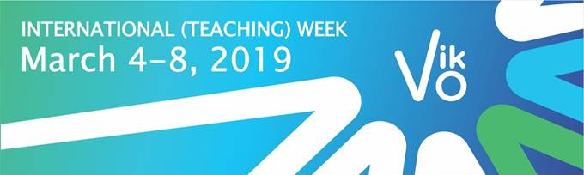

Dear Colleagues,

It’s a pleasure to invite you to take part in the **INTERNATIONAL WEEK**at**Vilniaus kolegija|University of Applied Sciences (Lithuania)!**

You will have an opportunity to teach students in another cultural and academic context, to meet staff of VIKO**|**UAS and colleagues from different countries.

•       Participation is possible in the framework of ERASMUS+ teacher**|**staff mobility.

•       We expect lecturers to teach our students min 8 academic hours.

•       Please fill in the registration till the 15th of February 2019.

We look forward to warmly welcome old friends and new acquaintances!

Don’t miss the opportunity to visit Vilnius, the capital of Lithuania, which is one of the UNESCO Word Heritage cities!

With the best regards  
Organisers of International Week  
Vilniaus kolegija**|**UAS